МИНОБРНАУКИ РОССИИ

Федеральное государственное бюджетное образовательное учреждение высшего образования

НИЖЕГОРОДСКИЙ ГОСУДАРСТВЕННЫЙ ТЕХНИЧЕСКИЙ
УНИВЕРСИТЕТ им. Р.Е.АЛЕКСЕЕВА

Институт радиоэлектроники и информационных технологий
Кафедра информатики и систем управления
Создание веб-сайтов
__________________________________________________________________
(наименование темы проекта или работы)

ПОЯСНИТЕЛЬНАЯ ЗАПИСКА
Отчет по лабораторной работе

РУКОВОДИТЕЛЬ:
________________ ______Савкин А.Е.__ _
(подпись) (фамилия, и.,о.)

СТУДЕНТ:
________________ _____Назарова.Д.А
(фамилия, и.,о.)

_________25-ПОВ
(шифр группы)

Работа защищена «___» ____________
С оценкой ________________________

Задание к выполнению лабораторной работы № 2

Задание на лабораторную работу:
Создание веб-сайта с использованием технологий HTML, CSS, JS
Цель работы:
Научиться создавать веб-сайты.
Ход работы:
Концепция
Работа над сайтом начинается с продумывания основной концепции и темы сайта. Мной была выбрана тема американского бренда сладостей. Сейчас много берут идей с запада по поводу сладостей и из-за этого тема мне стала интересна.
Основная страница
После того, как сформулирована концепция сайта, началась работа по созданию главной страницы, которая будет встречать посетителя сайта первой, поэтому уже на этом этапе была продумана навигация по сайту.
Страница с новостями
В качестве второй страницы была создана страница с новостями. Какие-же в наличие и какой выбор сладостей есть.

Вывод:
В этой лабораторной работе мы научились проектировать и создавать веб-сайты при помощи HTML, CSS и JS.

Приложение 1. Главная страница сайта
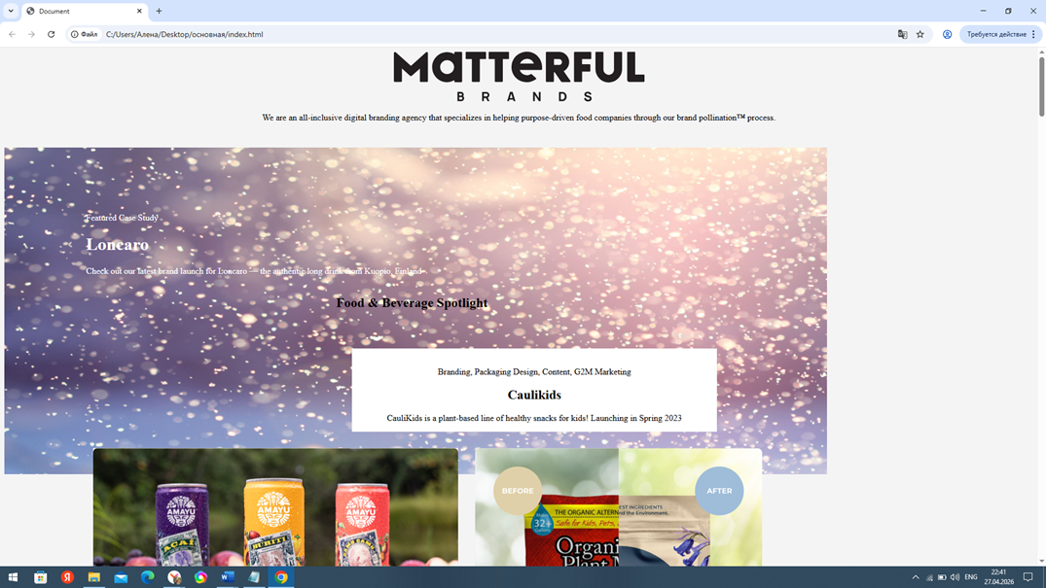

Приложение 2-3. Сладости от бренда на любой выбор
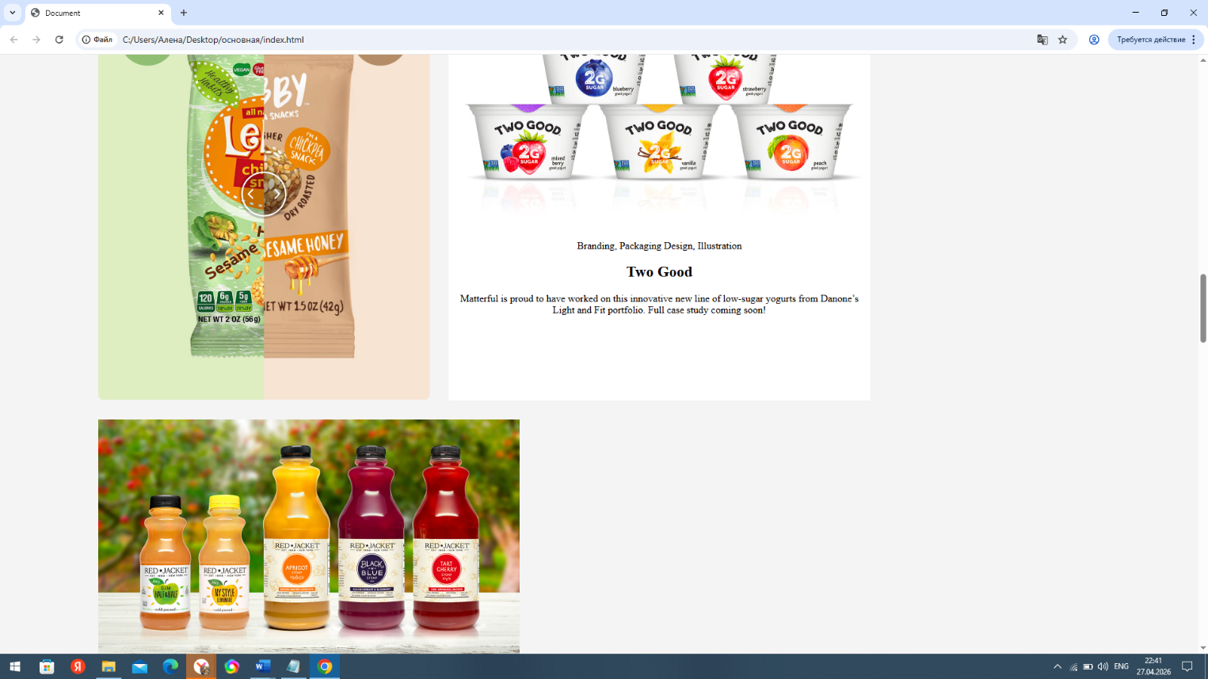

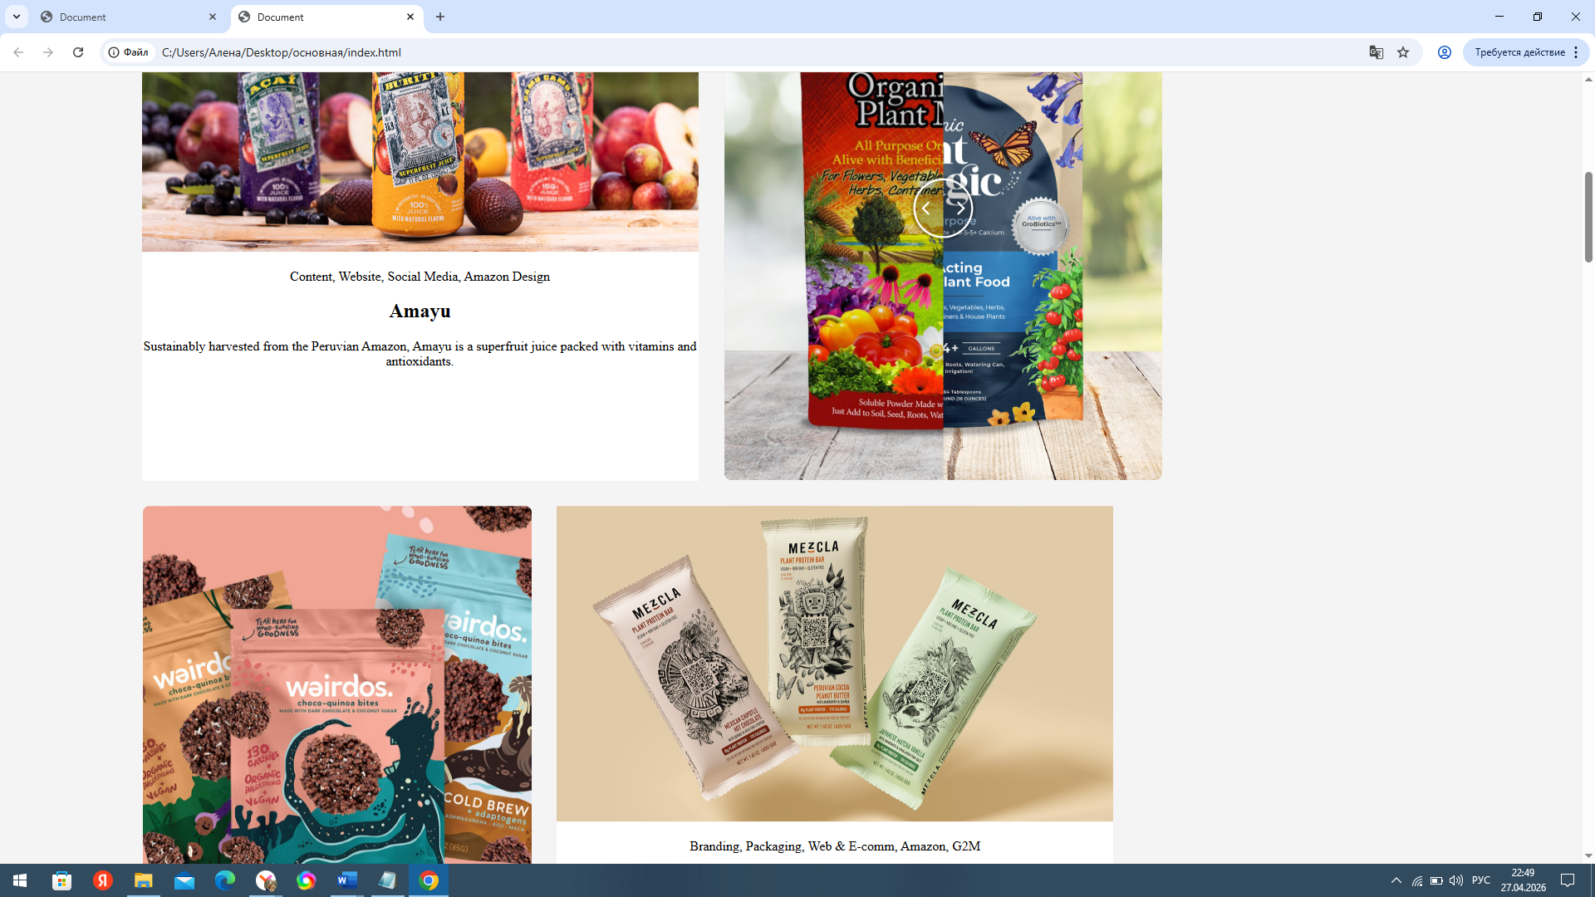

Приложение 4. Фотоотзывы
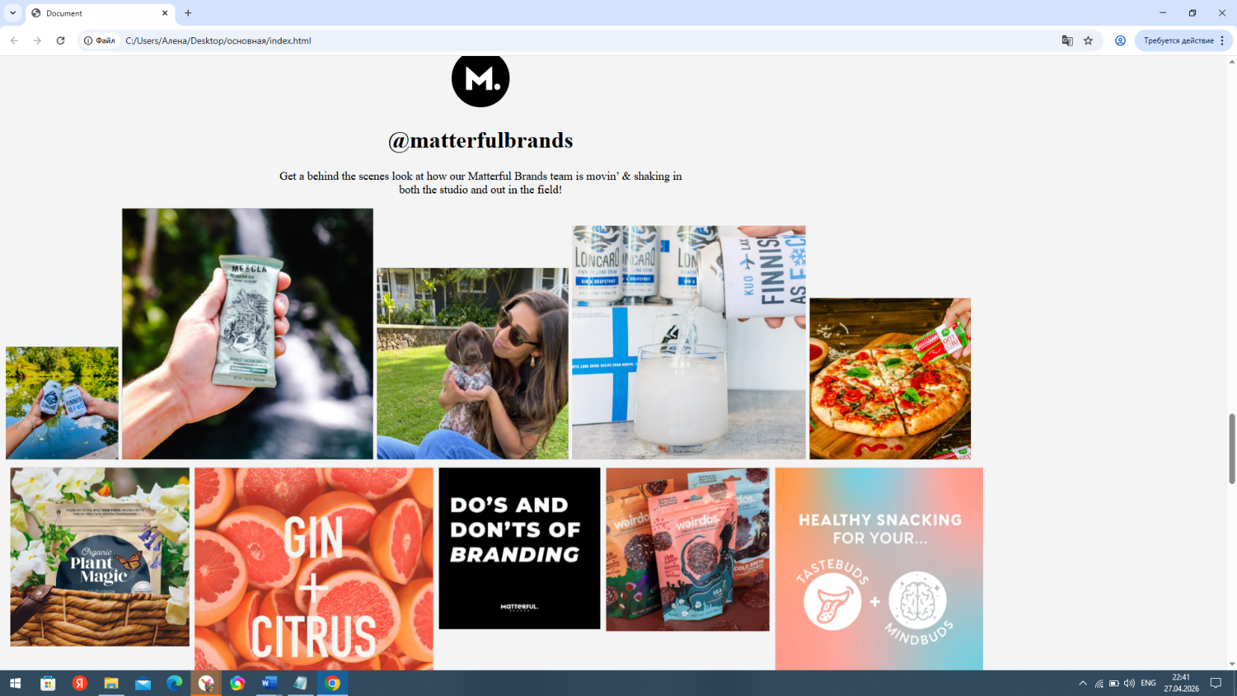

Приложение 5. Спонсоры сотрудничающие с брендом
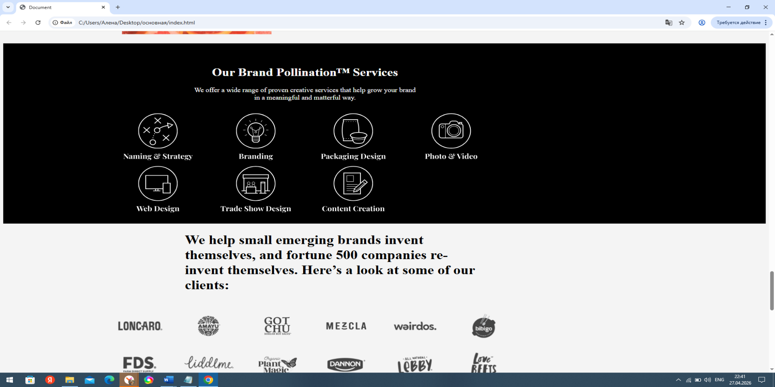

Приложение 6. Как связаться с брендом
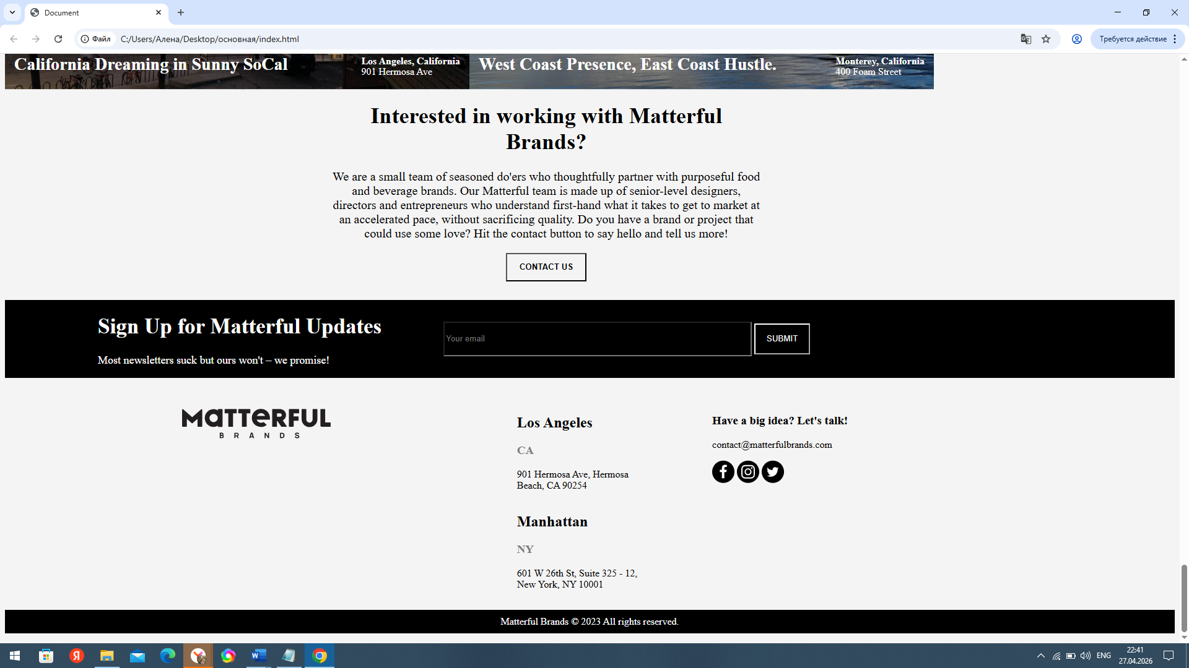

1)resert.
/* Reset and base styles */
* {
padding: 0px;
margin: 0px;
border: none;
}

*,
*::before,
*::after {
box-sizing: border-box;
}

/* Links */

a, a:link, a:visited {
text-decoration: none;
}

a:hover {
text-decoration: none;
}

/* Common */

aside, nav, footer, header, section, main {
display: block;
}

h1, h2, h3, h4, h5, h6, p {
font-size: inherit;
font-weight: inherit;
}

ul, ul li {
list-style: none;
}

img {
vertical-align: top;
}

img, svg {
max-width: 100%;
height: auto;
}

address {
font-style: normal;
}

/* Form */

input, textarea, button, select {
font-family: inherit;
font-size: inherit;
color: inherit;
background-color: transparent;
}

input::-ms-clear {
display: none;
}

button, input[type="submit"] {
display: inline-block;
box-shadow: none;
background-color: transparent;
background: none;
cursor: pointer;
}

input:focus, input:active,
button:focus, button:active {
outline: none;
}

button::-moz-focus-inner {
padding: 0;
border: 0;
}

label {
cursor: pointer;
}

legend {
display: block;
}

2)style
body {
padding: 0;
background-color: rgba(244, 244, 244, 1);
}

.logo {
display: block;
justify-content: center;
}
.glava {
display: block;
justify-content: center;
text-align: center;
}

.main-lonkaro {
display: flex;
justify-content: space-between;
margin-top: -120px;
max-width: 100%;
width: 100%;
height: auto;;
-webkit-background-size: cover;
background-size: cover;
}
.main-lonkaro1 {
display: flex;
margin-top: -500px;
}
.main-lonkaro1 img {
margin-left: 200px;
}
.lonkaro {

display: block;
margin-top: 150px;
}
.lonkaro1 {
z-index: 10;
color: #fff;
max-width: 800px;
width: 100%;
margin-left: 150px;
}
.name {
display: flex;
text-align: center;
justify-content: center;
}
.home {
display: flex;
justify-content: center;
flex-wrap: wrap;
width: 1200px;
}
main {
width: 1200px;
margin-left: 148px;
}
.home-men {
display: flex;
}
.home-item {
display: block;
margin-left: 800px;
}
.home-item-down {
width: 670px;
}

.home-down {
display: flex;
flex-wrap: wrap;
}
.cart {
padding-top: 30px;

}
.cart1 {
margin-top: -50px;
}
.home-down-item1 {
width: 670px;
display: block;
margin-right: 30px;
text-align: center;
padding-top: 50px;
background-color: #fff;
height: 606px;
padding-right: 0px;
padding-left: 0px;
margin-top: 30px;
}
.home-down-item12 {
margin-left: 450px;
width: 670px;
background-color: #fff;
margin-top: 50px;
display: block;

text-align: center;
padding-right: 0px;
padding-left: 0px;
}
.home-down-item123 {
width: 570px;
background-color: #fff;
display: block;
padding-right: 20px;
padding-left: 20px;
text-align: center;
padding-right: 0px;
padding-left: 0px;
margin-right: 30px;
margin-top: 80px;
}
.home-down-item1234 {
width: 670px;
display: block;
margin-left: 30px;
margin-top: 30px;
text-align: center;
padding-top: 50px;
background-color: #fff;
height: 606px;
padding-right: 0px;
padding-left: 0px;
}
.first {
display: flex;
}
.home-down-item2 {
width: 670px;
}
.two {
display: flex;
justify-content: space-between;
}
.three {
display: flex;
justify-content: space-between;
}
.nome-container {
width: 670px;
}
.home-down-item3 {
width: 570px;
display: block;
text-align: center;
}

.glava1 {
margin-top: 25px;
display: block;
text-align: center;
width: 660px;
font-size: 18px;
margin-left: 408px;
}

.side-down {
display: flex;
align-items: start;
}

.brand {
background-color: black;
padding-top: 40px;
margin-top: 25px;
color: #fff;
max-width: 100%;
width: 100%;
height: auto;;
-webkit-background-size: cover;
background-size: cover;
}
.offer {
width: 555px;
margin-left: 470px;
text-align: center;
}
.offer p {
font-size: 18px;
}
.znaks {
width: 1000px;
display: flex;
flex-wrap: wrap;
margin-left: 270px;
padding-bottom: 30px;
}
.mini {
margin-top: 15px;
margin-right: 15px;
}

.sponsors h1 {
width: 720px;
font-size: 36px;
margin-left: 450px;
}

.spons {
display: flex;
flex-wrap: wrap;
margin-left: 270px;
width: 1100px;
}
.sik {
margin-right: 30px;
margin-top: 30px;
}
.lower {
display: block;
text-align: center;
}
.quatro {
width: 16px;
height: 10px;
background-color: black;
margin-left: 100vh;
}
.cartina {
display: flex;
margin-top: 30px;
color: #fff;
}

.socal1 {
display: flex;
justify-content: space-between;
margin-top: -80px;
padding-right: 15px;
padding-left: 15px;
}
.socal1 h1 {
font-size: 28px;
}
.calif p {
margin-top: -22px;
}

.contacs {
width: 700px;
text-align: center;
margin-left: 55vh;
}
.contacs h1 {
font-size: 36px;
}
.contacs p {
font-size: 20px;
}
.btn-contact {
height: 46px;
width: 130px;
background-color: rgba(244, 244, 244, 1);
font-weight: bold;
}
.sign {
margin-top: 30px;
background-color: black;
color: #fff;
display: flex;
align-items: center;
}
.notup {
width: 600px;
margin-left: 100px;
}
.side-hight img {
margin-left: 1px;
margin-bottom: 8px;
}
.side-down img {
margin-left: 8px;
}
.up {
margin-left: 150px;
}
.up h1 {
font-size: 35px;
}
.up p {
font-size: 18px;
}
.email {
background-color: black;
color: #fff;
width: 490px;
height: 50px;
}
.sub {
background-color: black;
overflow: hidden;
color: #fff;
border-color: #fff;
width: 90px;
height: 50px;
}

.foot {
display: flex;
}
.mate {
margin-left: 30vh;
margin-top: 50px;
}
.hour {
margin-left: 30vh;
}
.clock {
margin-top: 40px;
margin-right: 15px;
}
.manhten {
display: flex;
margin-top: 40px;
}
.los {
display: flex;
}
.info {
display: block;
width: 220px;
}
.info h3 {
opacity: 50%;
}
.twiter {
margin-left: 10vh;
}
.slog {
text-align: center;
color: #fff;
background-color: black;
}
.slog p {
padding-top: 10px;
padding-bottom: 10px;
}

/* @media(max-width: 1500px)
{
.galery {
display: none;
}
.brand {
width: 100%;
}
}
@media(min-width: 1300px)
{
.brand {
width: 100%;
}
} */

@media (max-width: 500px) {
body {
margin: 0;
}
.logo img {
width: 250px;
margin-top: 40px;
}
.text {
width: 350px;
text-align: center;
margin-left: 30px;
}
p {
font-size: 14px;
}

main {
width: 100vw;
margin: 0 auto;
margin-top: 100px;
}

.home {
width: 100vw;
flex-direction: column;
flex-wrap: nowrap;
row-gap: 50px;
}

.home-men {
display: block;
width: 100vw;
margin: 0 auto;
text-align: center;
}

.home-down-item12 {
width: 300px;
margin: 0 auto;
}

.home-down-item12 p {
font-size: 14px;
padding: 6px 6px;
}

.cart12 {
width: 300px;
}

.home-down-item1 {
width: 300px;
height: auto;
margin: 0 auto;
margin-bottom: 50px;
}

.home-down-item1 p {
padding: 6px 6px;
}

.cart1 {
width: 300px;
}

.cart {
width: 80vw;
height: auto;
margin: 0 auto;
padding-top: 0;
}

.home-down-item1234 {
width: 300px;
height: auto;
margin: 30px auto;
}

.home-down-item1234 p {
padding: 6px 6px;
}

.first {
flex-direction: column;
margin: 0 auto;
}

.two {
flex-direction: column;
margin: 0 auto;
}

.three {
flex-direction: column;
margin: 0 auto;
}

.home-down-item123 {
width: 100vw;
margin-right: 0;
margin-bottom: 30px;
}

.home-down-item123 p {
padding: 0 6px;
}

.galery {
display: none;
}

nav {
width: 100vw;
}

.container {
margin-top: 30px;
width: 100vw;
}

.glava1 {
width: 100vw;
margin-left: 0;
margin: 0 auto;
}

.glava1 p {
padding: 0 6px;
}

.brand {
width: 100vw;
}

.offer {
width: 380px;
margin-left: 0;
margin: 0 auto;
}

.znaks {
width: 100vw;
margin-left: 0;
justify-content: center;
}

.mini {
width: 192px;
}
.main-lonkaro1 {
display: block;
margin-left: 0;
margin-top: -400px;
}
.lonkaro1 {
padding: 0;
width: 250px;
margin-left: 30px;
}
.lonkaro1 h1 {
margin-top: -5px;
}
.mini-p {
margin-top: -8px;
}
.main-lonkaro1 img {
margin-left: 0;
width: 400px;
height: auto;
}
.back-img {
height: 400px;
width: 100%;
}
.cartina {
display: block;
width: 420px;
height: auto;
}
.calif {
margin-top: -20px;
}
.calif h4 {
font-size: 15px;
width: 120px;
}
.socal1 h1 {
margin-top: -10px;
font-size: 20px;
width: 200px;
}
.socal img {
width: 420px;
}
.sign {
display: block;
width: 420px;
}
.up {
width: 320px;
margin-left: 20px;
}
.notup {
display: block;
margin-left: 20px;
padding-bottom: 15px;
}
.email {
width: 240px;
}
.sponsors {
display: block;
width: 380px;
}
.sponsors h1 {
font-size: 26px;
width: 360px;
margin-left: 0;
width: 100%;
margin-left: 15px;
margin-right: 20px;
}
.spons {
display: block;
width: 100%;
margin-left: 8vw;
}
.lower {
width: 100%;
margin-left: 0;
}
.quatro {
margin-left: 45vw;
}
.contacs {
display: block;
width: 380px;
margin-left: 15px;
}
.contacs p {
font-size: 18px;
}
.contacs h1 {
font-size: 26px;
}
.foot {
display: block;
}
.mate {
margin-left: 90px;
}
.manhten {
width: 400px;
display: block;
}
.los {
margin-left: -240px;
}
.crugi {
margin-left: 11vw;
}
}

3) index
<!DOCTYPE html>
<html lang="en">
<head>
<meta charset="UTF-8">
<meta name="viewport" content="width=device-width, initial-scale=1.0">
<link rel="stylesheet" href="style.css">
<title>Document</title>
</head>
<body>
<header>
<div class="glava">
<div class="logo">
<img src="./img/Vector.svg" alt="">
</div>
<div class="text">
<p>We are an all-inclusive digital branding agency that specializes
in helping purpose-driven food companies through our brand pollination™ process.</p>
</div>
</div>
<div class="main-lonkaro">
<div class="lonkaro">
<img src="./img/back.jpg" alt="" width="1510" height="600px" class="back-img">
<div class="main-lonkaro1">
<div class="lonkaro1">
<p>Featured Case Study</p>
<h1>Loncaro</h1>
<p class="mini-p">Check out our latest brand launch for Loncaro — the authentic long drink from Kuopio, Finland</p>
</div>

<img src="./img/home-loncaro.webp.svg" alt="">
</div>
</div>
</div>
</header>
<main>
<h2 class="name">Food & Beverage Spotlight</h2>
<div class="home">
<div class="home-down-item12">
<img src="./img/div.callout-image.svg" alt="" class="cart12">
<p>Branding, Packaging Design, Content, G2M Marketing</p>
<h2>Caulikids</h2>
<p>CauliKids is a plant-based line of healthy snacks for kids!
Launching in Spring 2023</p>
</div>
<div class="home-men">
<div class="home-down-item1">
<img src="./img/candy.svg" alt="" class="cart1">
<p>Content, Website, Social Media, Amazon Design</p>
<h2>Amayu</h2>
<p>Sustainably harvested from the Peruvian Amazon, Amayu is a superfruit juice packed with vitamins and antioxidants.</p>
</div>
<img src="./img/pacet.svg" alt="" class="cart">
</div>
<div class="home-men">
<img src="./img/pachka.svg" alt="" height="607px" class="cart">
<div class="home-down-item1234">
<img src="./img/baton.svg" alt="" class="cart1">
<p>Branding, Packaging, Web & E-comm, Amazon, G2M</p>
<h2>Mezcla</h2>
<p>Mezcla is arguably the fastest growing plant protein bar in the better-for-you space.
Each bar fuses art and food, featuring ingredients and designs from around the world.
</div>
</div>

</div>

<div class="home-down-item1">
<img src="./img/shaiba.svg" alt="" class="cart1">
<p>Branding, Packaging Design, Website</p>
<h2>Toum</h2>
<p>Toum is middle eastern garlic dip and spread made from all REAL ingredients.
Suspiciously healthy and deliciously addictive, you’ll want to put it on everything. We do!</p>
</div>

<div class="home-down">
<div class="first">
<img src="./img/lesby.svg" alt="" class="cart">
<div class="home-down-item1234">
<img src="./img/jogurt.svg" alt="" class="cart1">
<p>Branding, Packaging Design, Illustration</p>
<h2>Two Good</h2>
<p>Matterful is proud to have worked on this innovative new
line of low-sugar yogurts from Danone’s Light and Fit portfolio. Full case study coming soon!</p>
</div>
</div>
<div class="two">
<div class="home-down-item1">
<img src="./img/juice.svg" alt="" class="cart1">
<p>Packaging Design</p>
<h2>Red Jacket Juice</h2>
<p>Matterful redesigned several of Red Jackets core packaging products; including their
premium line of Stomps as well
as Joe’s Half & Half and NY-style Lemonade. Full case study coming soon.</p>
</div>
<img src="./img/coment.svg" alt="" class="cart">
</div>
<div class="three">
<div class="home-down-item123">
<img src="./img/box.svg" alt="" class="cart1">
<p>Packaging Design</p>
<h2>Love Beets</h2>
<p>Matterful recently helped Love Beets design an eco-friendly version of packaging design for their popular Cooked Beets sku.
Look-out for
these fun and whimsical packs in Target, Costco and other high-profile retailers nationwide!</p>
</div>
<img src="./img/coffee.svg" alt="" class="cart" width="570px">
</div>
</div>
</main>
<nav>
<div class="container">
<div class="glava1">
<img src="./img/mini-logo.svg" alt="" class="logo1">
<h1>@matterfulbrands</h1>
<p>Get a behind the scenes look at how our Matterful Brands team is movin’
& shaking in both the studio and out in the field!</p>
</div>

<div class="galery">
<div class="side-hight">
<img src="./img/foto1.svg" alt="" width="175px" height="auto">
<img src="./img/foto2.svg" alt="" width="391px" height="auto">
<img src="./img/foto3.svg" alt="" width="298px" height="auto">
<img src="./img/foto4.svg" alt="" width="363px" height="auto">
<img src="./img/foto5.svg" alt="" width="251px" height="auto">
</div>
<div class="side-down">
<img src="./img/foto6.svg" alt="" width="278px" height="auto">
<img src="./img/foto7.svg" alt="" width="371px" height="auto">
<img src="./img/foto8.svg" alt="" width="251px" height="auto">
<img src="./img/foto9.svg" alt="" width="255px" height="auto">
<img src="./img/foto10.svg" alt="" width="323px" height="auto">
</div>
</div>
<div class="brand">
<div class="offer">
<h1>Our Brand Pollination™ Services</h1>
<p>We offer a wide range of proven creative services that help grow your brand in a meaningful and matterful way.</p>
</div>
<div class="znaks">
<img src="./img/znak1.svg" alt="" class="mini" width="227px" height="auto">
<img src="./img/znak2.svg" alt="" class="mini" width="227px" height="auto">
<img src="./img/znak3.svg" alt="" class="mini" width="227px" height="auto">
<img src="./img/znak4.svg" alt="" class="mini" width="227px" height="auto">
<img src="./img/znak5.svg" alt="" class="mini" width="227px" height="auto">
<img src="./img/znak6.svg" alt="" class="mini" width="227px" height="auto">
<img src="./img/znak7.svg" alt="" class="mini" width="227px" height="auto">
<img src="./img/znak8.svg" alt="" class="mini" width="227px" height="auto">
</div>
</div>
<div class="sponsors">
<h1>We help small emerging brands invent themselves, and
fortune 500 companies re-invent themselves. Here’s a look at some of our clients:</h1>
<div class="spons">
<img src="./img/sik1.svg" alt="" class="sik" width="140px" height="auto">
<img src="./img/sik2.svg" alt="" class="sik" width="140px" height="auto">
<img src="./img/sik3.svg" alt="" class="sik" width="140px" height="auto">
<img src="./img/sik4.svg" alt="" class="sik" width="140px" height="auto">
<img src="./img/sik5.svg" alt="" class="sik" width="140px" height="auto">
<img src="./img/sik6.svg" alt="" class="sik" width="140px" height="auto">
<img src="./img/sik7.svg" alt="" class="sik" width="140px" height="auto">
<img src="./img/sik8.svg" alt="" class="sik" width="140px" height="auto">
<img src="./img/sik9.svg" alt="" class="sik" width="140px" height="auto">
<img src="./img/sik10.svg" alt="" class="sik" width="140px" height="auto">
<img src="./img/sik11.svg" alt="" class="sik" width="140px" height="auto">
<img src="./img/sik12.svg" alt="" class="sik" width="140px" height="auto">
</div>
<div class="lower">
<p>Expand to view more</p>
<div class="quatro"></div>
</div>
</div>
<div class="cartina">

<div class="socal">
<img src="./img/sunny.svg" alt="" width="750px" height="auto">
<div class="socal1">
<h1>California Dreaming in Sunny SoCal</h1>

<div class="calif">
<h4>Los Angeles, California</h4>
<p>901 Hermosa Ave</p>
</div>
</div>
</div>

<div class="socal">
<img src="./img/west.svg" alt="" width="750px" height="auto">
<div class="socal1">
<h1>West Coast Presence, East Coast Hustle.</h1>
<div class="calif">
<h4>Monterey, California</h4>
<p>400 Foam Street</p>
</div>
</div>

</div>

</div>
<div class="contacs">
<h1>Interested in working with Matterful Brands?</h1>
<p>We are a small team of seasoned do'ers who thoughtfully partner with purposeful food and beverage brands.
Our Matterful team is made up of senior-level designers, directors and entrepreneurs who understand first-hand
what it takes to get to market at an accelerated pace, without sacrificing quality. Do you have a brand or project
that could use
some love? Hit the contact button to say hello and tell us more!</p>
<button class="btn-contact">CONTACT US</button>
</div>
<div class="sign">
<div class="up">
<h1>Sign Up for Matterful Updates</h1>
<p>Most newsletters suck but ours won't – we promise!</p>
</div>
<div class="notup">
<input type="text" placeholder="Your email" class="email">
<button class="sub">SUBMIT</button>
</div>
</div>
</div>
</nav>
<footer>
<div class="foot">
<div class="mate">
<img src="./img/mate.svg" alt="">
</div>
<div class="manhten">
<div class="hour">
<div class="los">
<div class="clock"><img src="./img/clock1.svg" alt=""></div>
<div class="info">
<h2>Los Angeles</h2>
<h3>CA</h3>
<p>901 Hermosa Ave, Hermosa Beach, CA 90254</p>
</div>
</div>
<div class="los">
<div class="clock"><img src="./img/clock2.svg" alt=""></div>
<div class="info">
<h2>Manhattan</h2>
<h3>NY</h3>
<p>601 W 26th St, Suite 325 - 12,
New York, NY 10001</p>
</div>
</div>
</div>
<div class="twiter">
<h3>Have a big idea? Let's talk!</h3>
<p>contact@matterfulbrands.com</p>
<div class="crugi">
<img src="./img/facebook.svg" alt="">
<img src="./img/insta.svg" alt="">
<img src="./img/twit.svg" alt="">
</div>
</div>
</div>
</div>
<div class="slog">
<p>Matterful Brands © 2023 All rights reserved.</p>
</div>
</footer>
</body>
</html>

